**Guia 19 : Swipe en android.**

1. Crear un proyecto nuevo

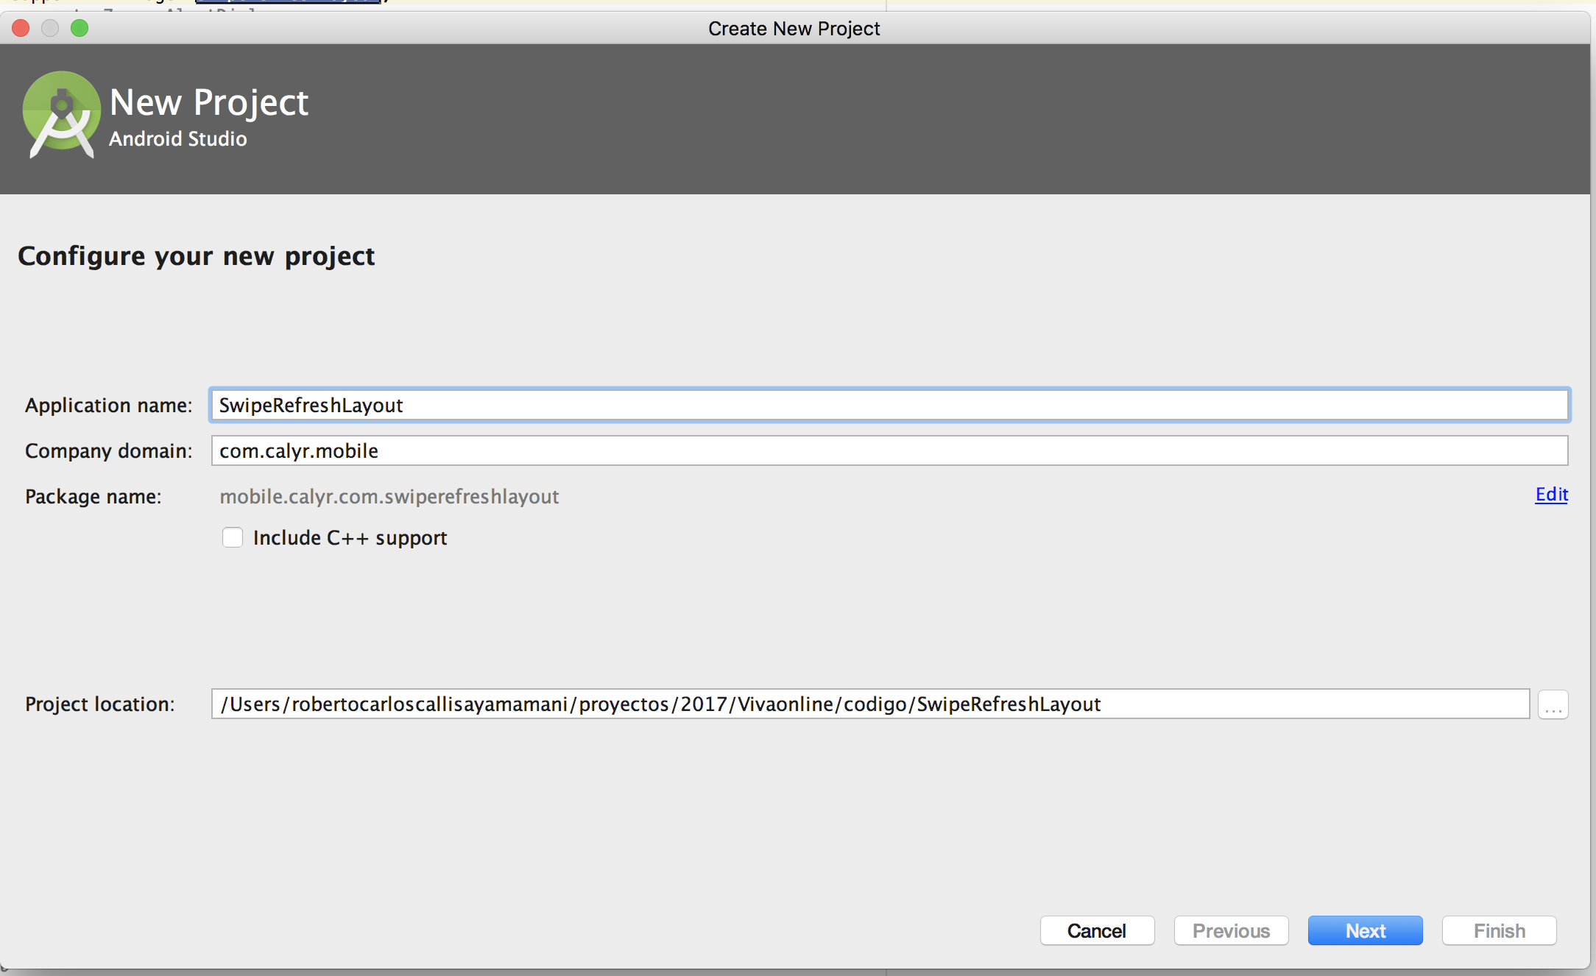

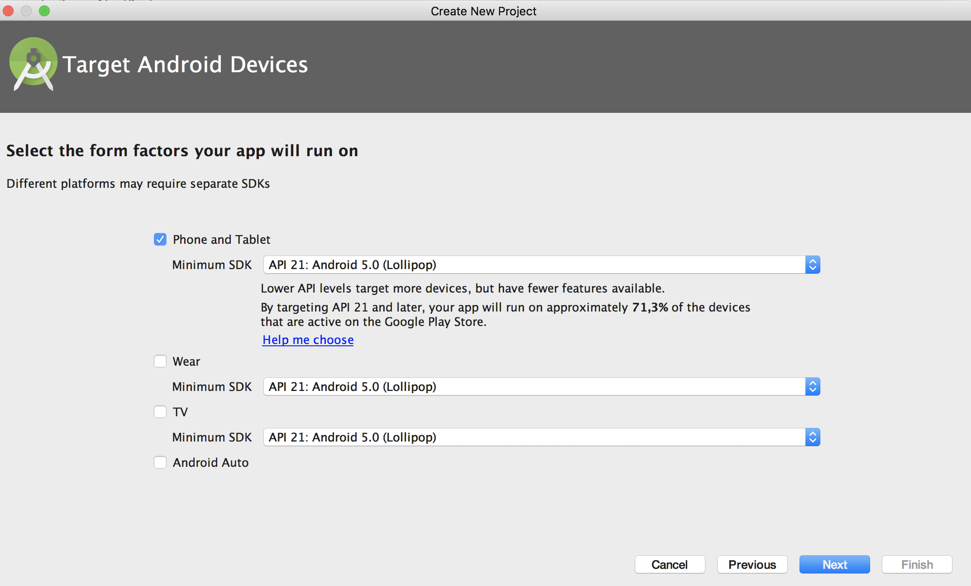

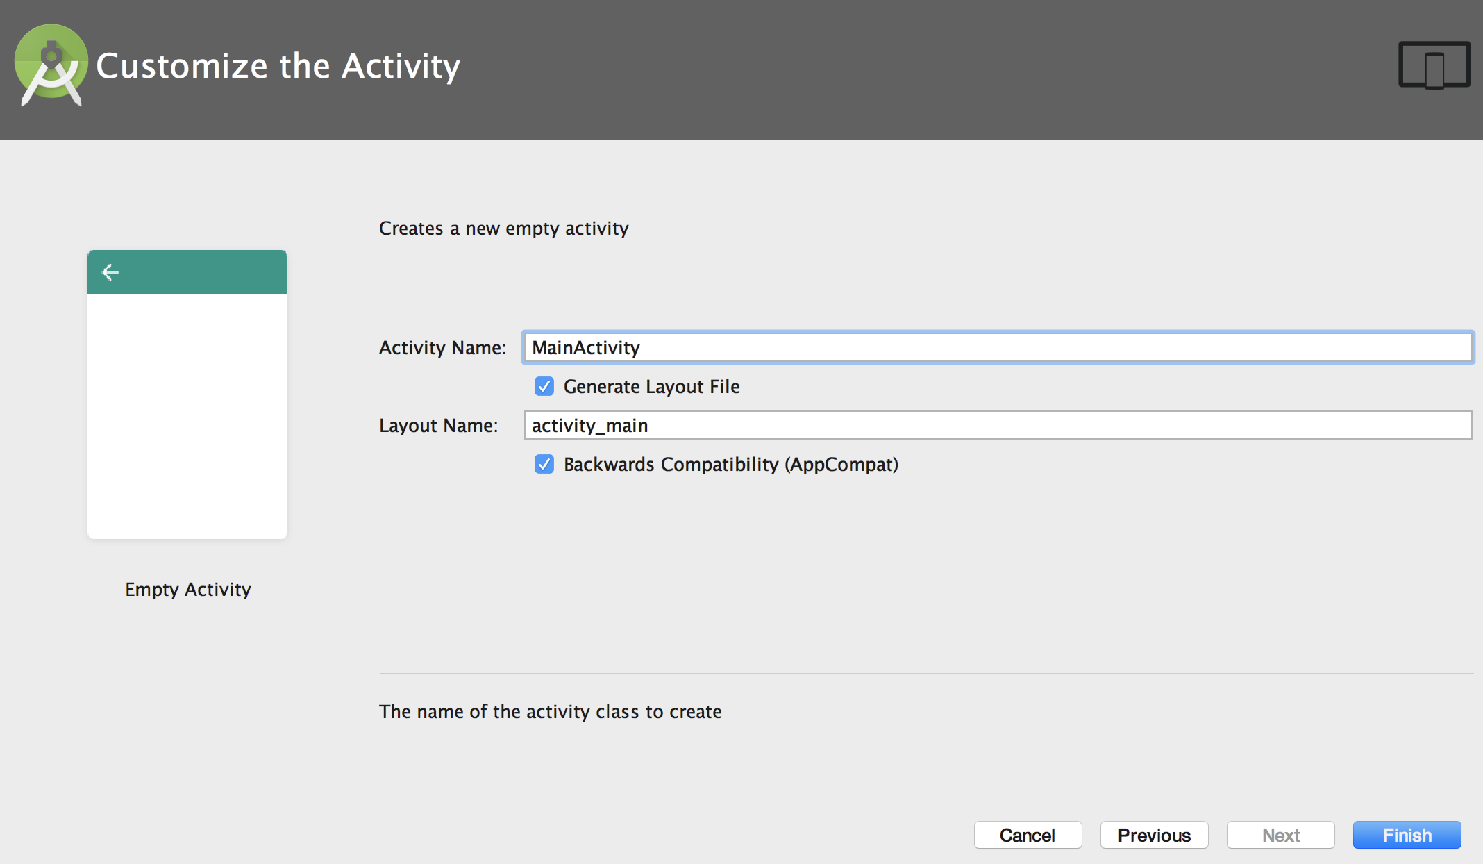

2. Modificar el activity_main.xml y agregar el siguiente view.

*<?***xml version="1.0" encoding="utf-8"***?>*

<**LinearLayout xmlns:android="http://schemas.android.com/apk/res/android"**

**xmlns:app="http://schemas.android.com/apk/res-auto"**

**xmlns:tools="http://schemas.android.com/tools"**

**android:layout_width="match_parent"**

**android:layout_height="match_parent"**

**android:orientation="vertical"**

**tools:context="mobile.calyr.com.swiperefreshlayout.MainActivity"**>

<**android.support.v4.widget.SwipeRefreshLayout xmlns:android="http://schemas.android.com/apk/res/android"**

**android:layout_width="match_parent"**

**android:id="@+id/swipe_to_refresh_layout"**

**android:layout_height="match_parent"**

**android:orientation="vertical"**>

<**TextView**

**android:layout_width="wrap_content"**

**android:layout_height="wrap_content"**

**android:text="Hello World!"**

**app:layout_constraintBottom_toBottomOf="parent"**

**app:layout_constraintLeft_toLeftOf="parent"**

**app:layout_constraintRight_toRightOf="parent"**

**app:layout_constraintTop_toTopOf="parent"** />

</**android.support.v4.widget.SwipeRefreshLayout**>

</**LinearLayout**>

3. Modificar la clase MainActivity.java para agregar la caracteristica de ocultarse.

**package** mobile.calyr.com.swiperefreshlayout;

**import** android.os.Bundle;

**import** android.support.v4.widget.SwipeRefreshLayout;

**import** android.support.v7.app.AppCompatActivity;

**import** android.util.Log;

**public class** MainActivity **extends** AppCompatActivity {

**private static final** String ***TAG*** = MainActivity.**class**.getSimpleName();

**private** SwipeRefreshLayout **swipeRefreshLayout**;

@Override

**protected void** onCreate(Bundle savedInstanceState) {

**super**.onCreate(savedInstanceState);

setContentView(R.layout.***activity_main***);

**this**.**swipeRefreshLayout** = ( SwipeRefreshLayout) findViewById(R.id.***swipe_to_refresh_layout***);

**swipeRefreshLayout**.setOnRefreshListener(**new** SwipeRefreshLayout.OnRefreshListener() {

@Override

**public void** onRefresh() {

Log.*i*(***TAG***, **"Ingreso a refresh"**);

**swipeRefreshLayout**.setRefreshing(**false**);

}

});

}

}